Optimization of Deep Learning Models for Embedded Systems Leather Implementation

Model Compression techniques:

1: Structured Channel Pruning
Structured channel pruning experiments were performed on three convolutional neural network architectures:
- MobileNetV2
- VGG16
- ResNet50
For each architecture, channels were ranked using the L1-Norm filter importance criterion. Channels with the lowest importance scores were removed, and the corresponding network architecture was reconstructed by physically eliminating the selected channels. Weight transfer mechanisms were implemented to initialize the reduced models using the trained baseline weights, followed by fine-tuning to recover any loss in accuracy.
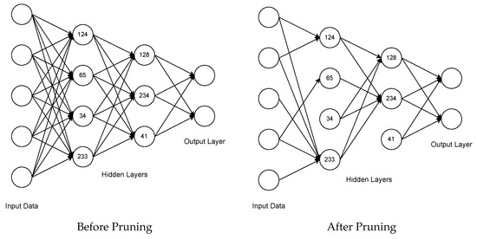

i) VGG16
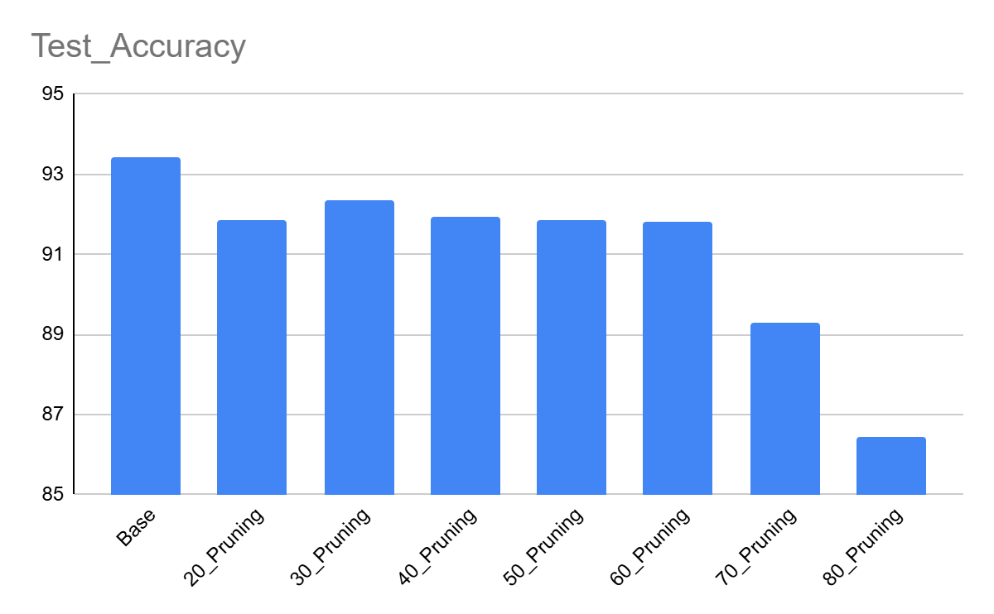
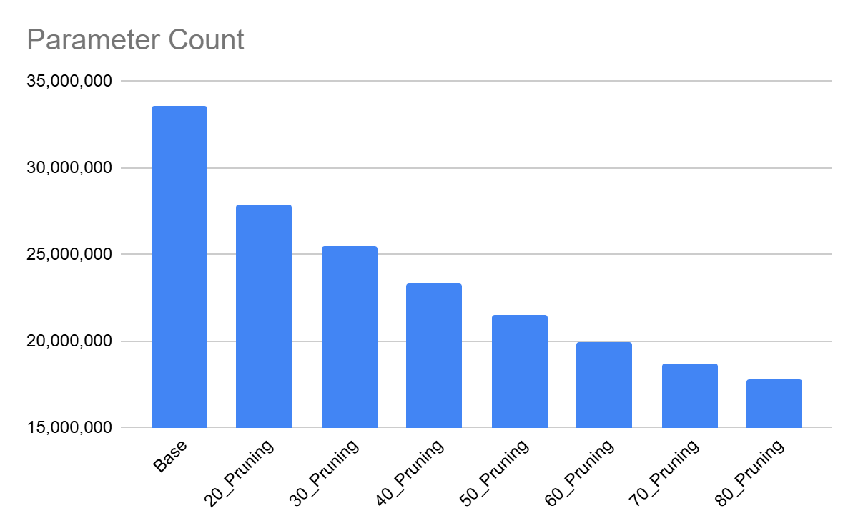
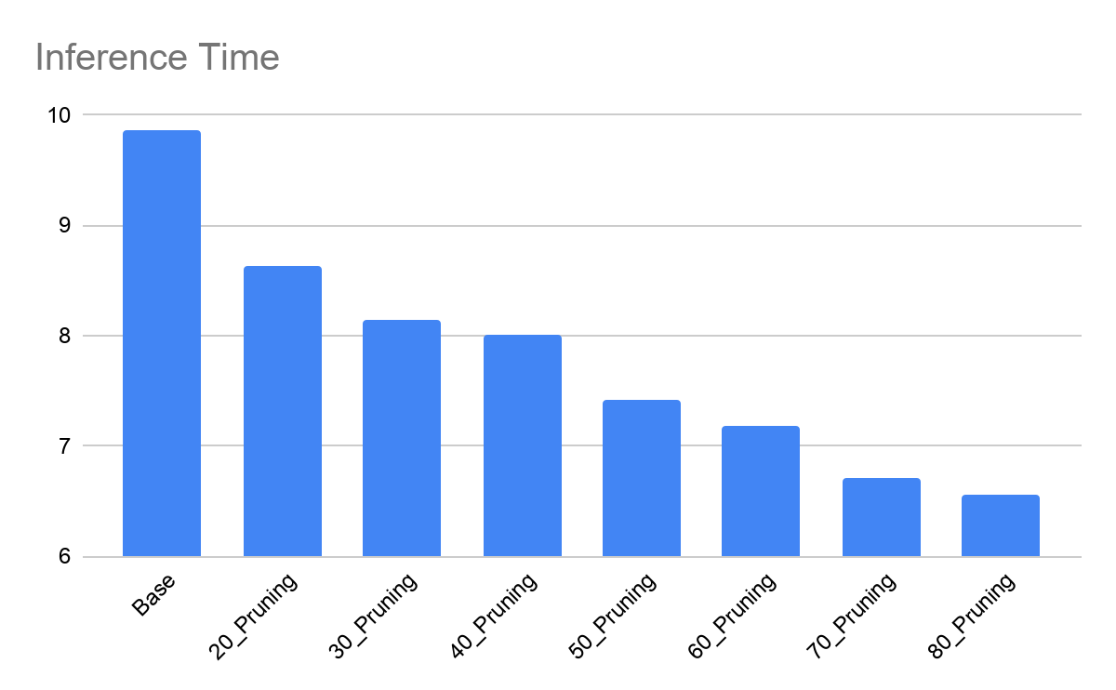
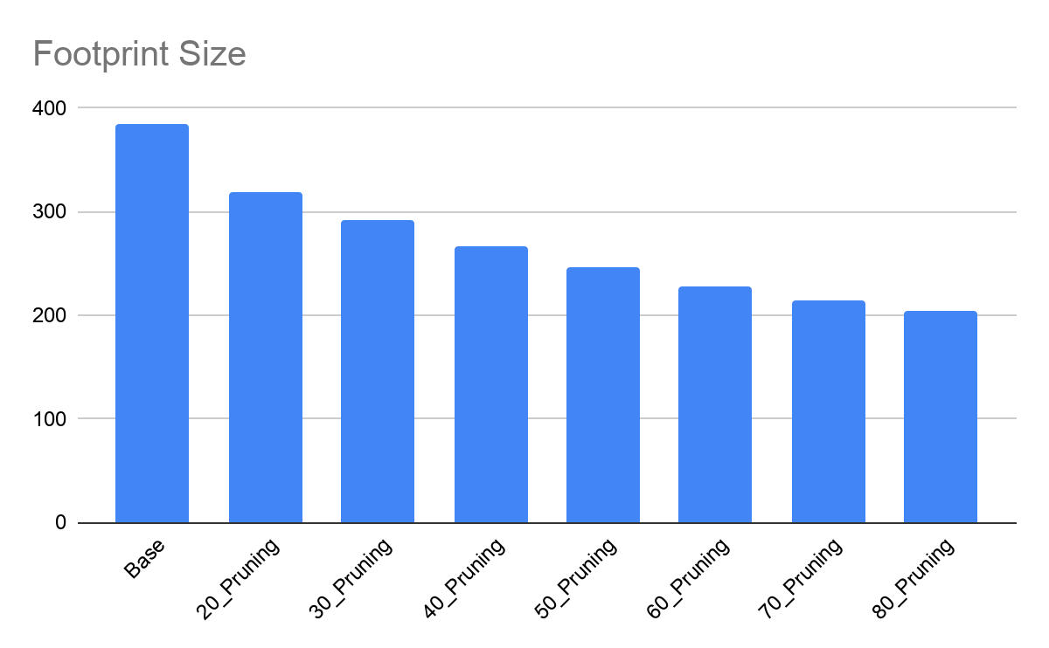

ii) MobileNetV2
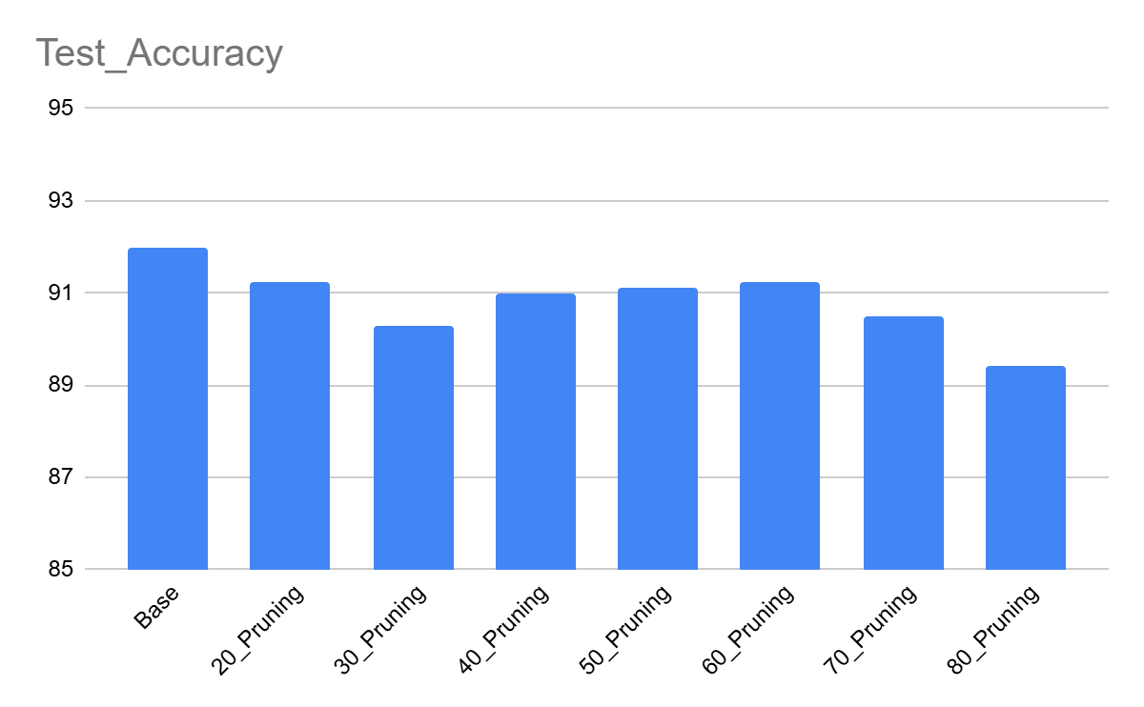
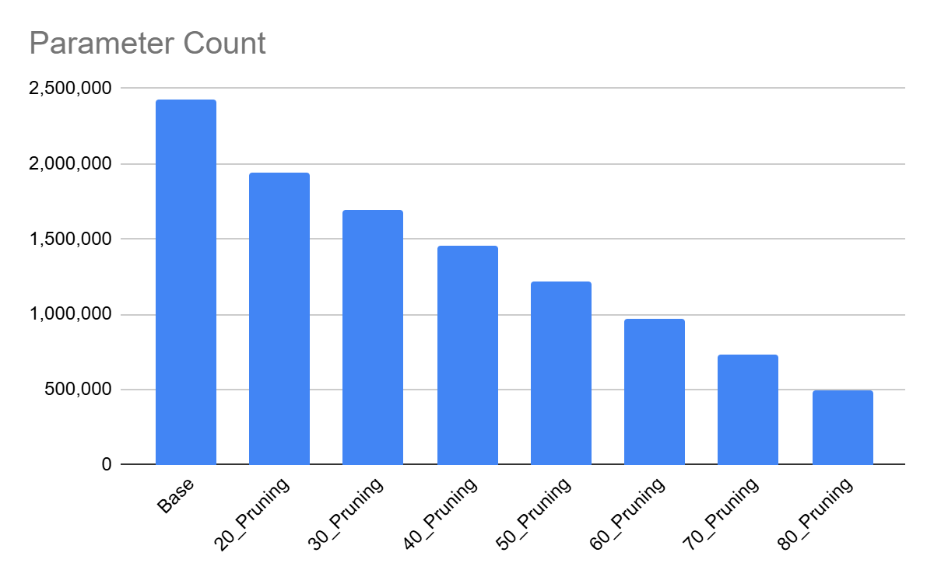
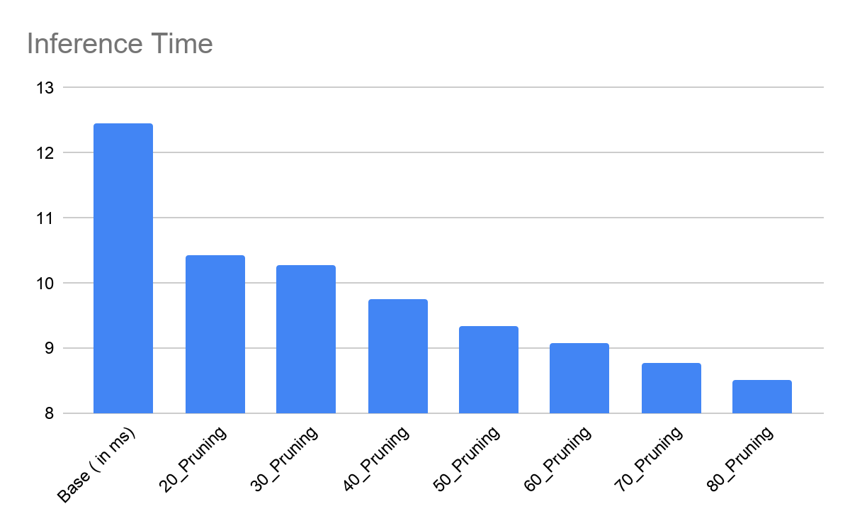
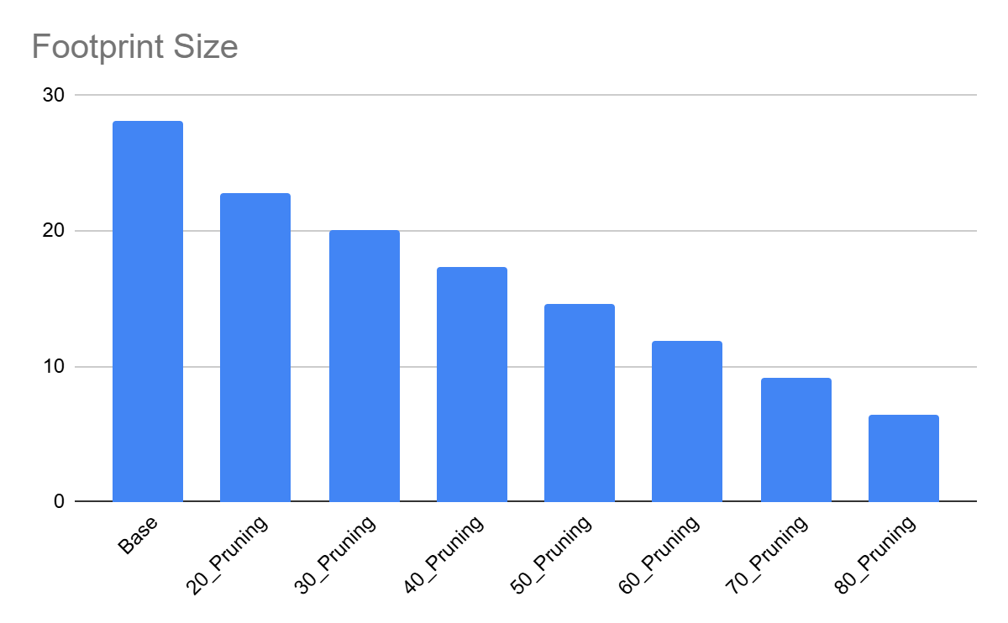

iii) ResNet50
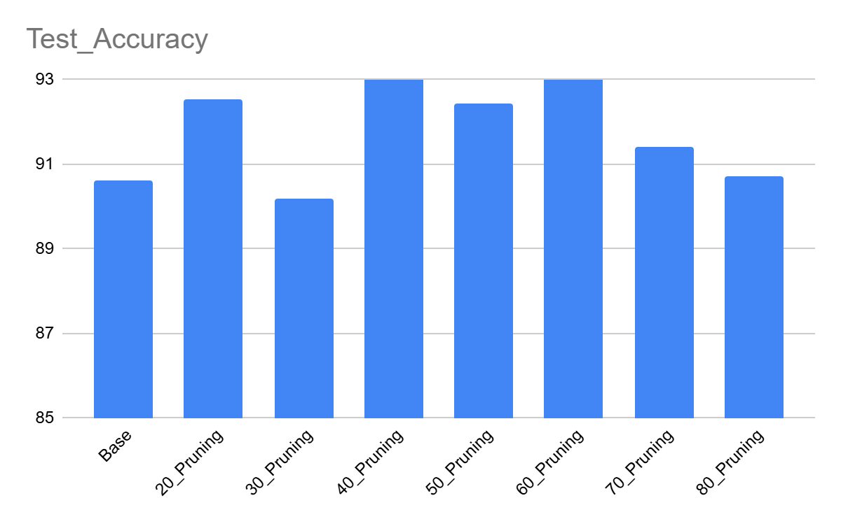
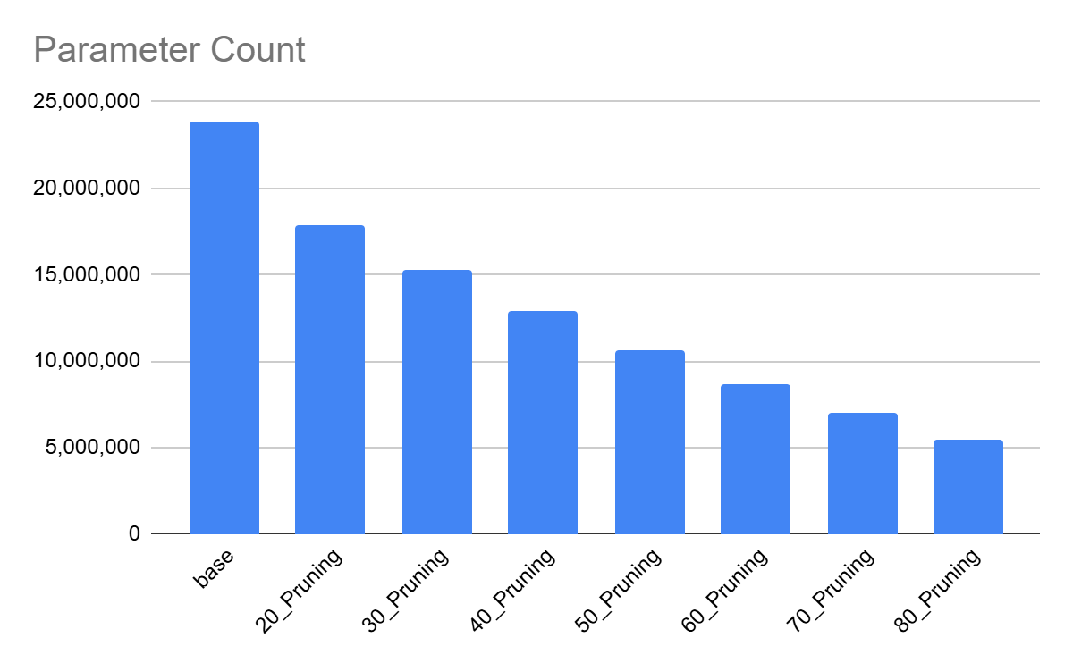
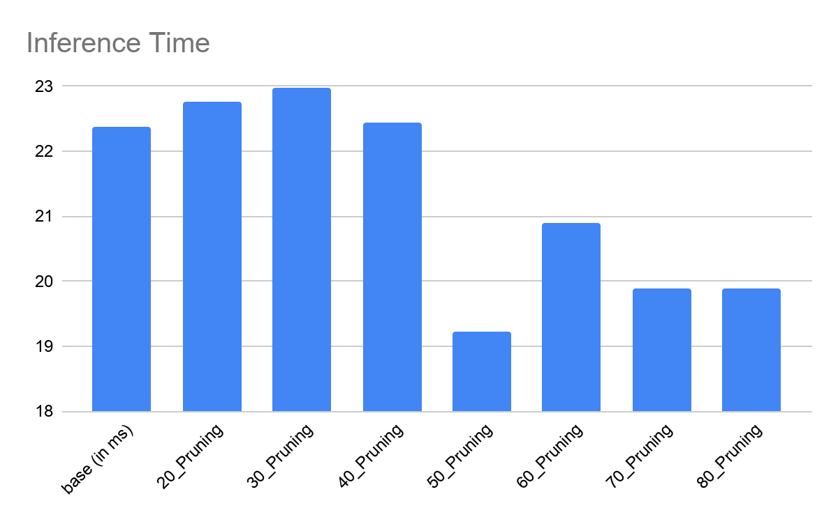
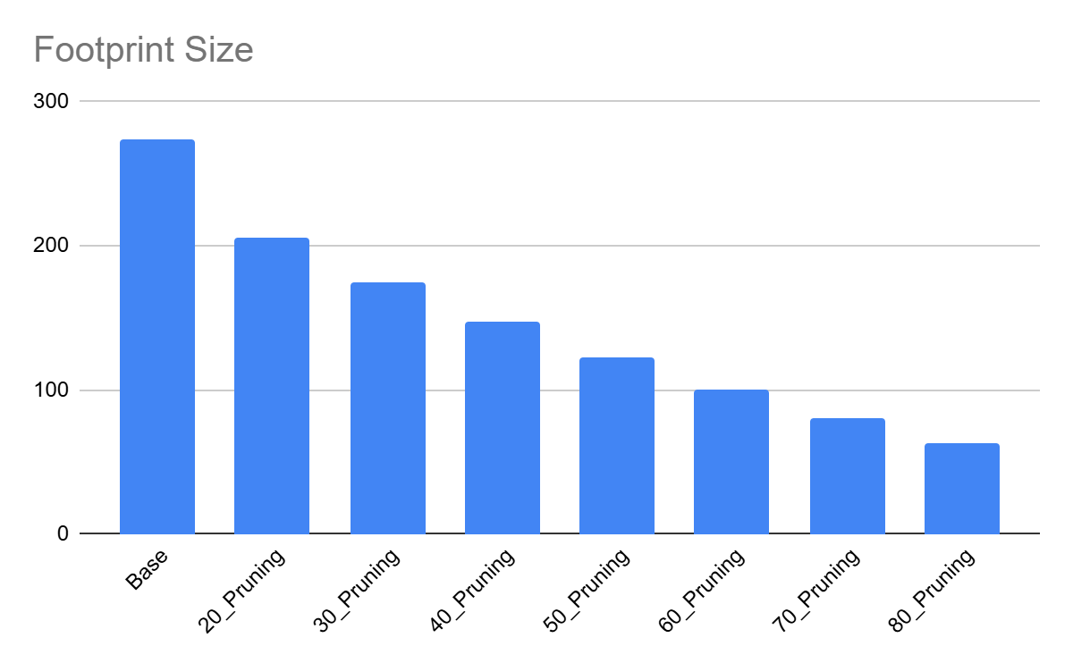

2: Dropout Regularization Study :
To investigate the impact of regularization on model generalization, dropout experiments were conducted on:
- MobileNetV2
- VGG16
- ResNet50

Dropout regularization was implemented by randomly deactivating a specified fraction of neurons during each training iteration, preventing co-adaptation among features and reducing overfitting. Multiple dropout ratios were evaluated to study their effect on model generalization, training stability, and classification performance, while keeping the network architecture and other training parameters unchanged (for the most part).

i) VGG16
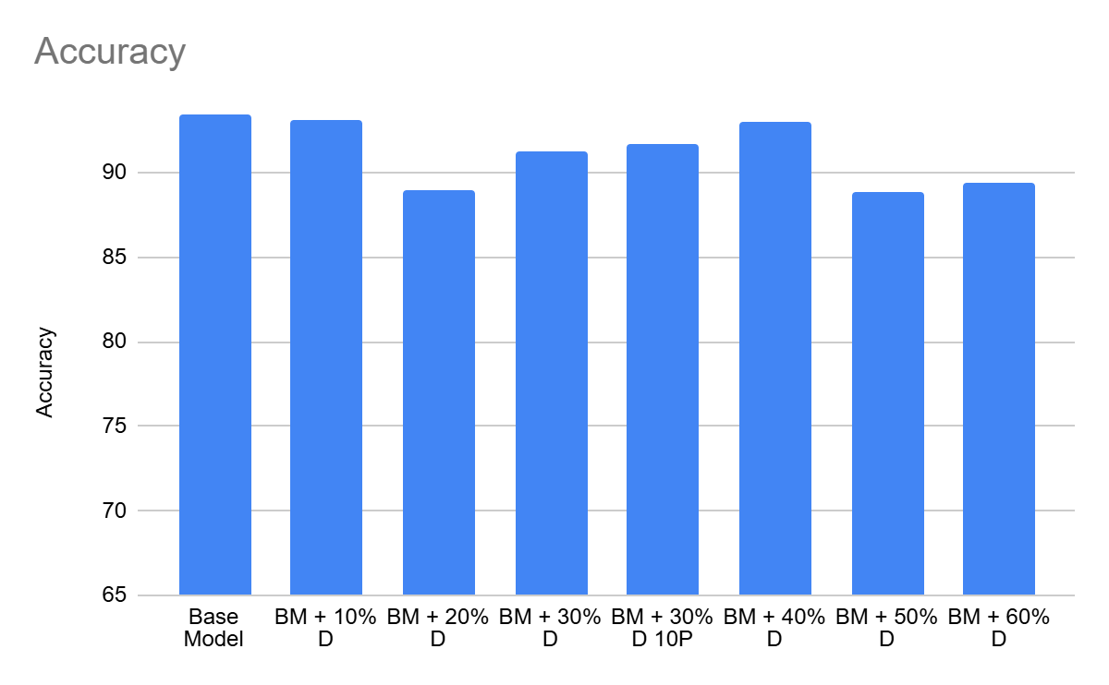
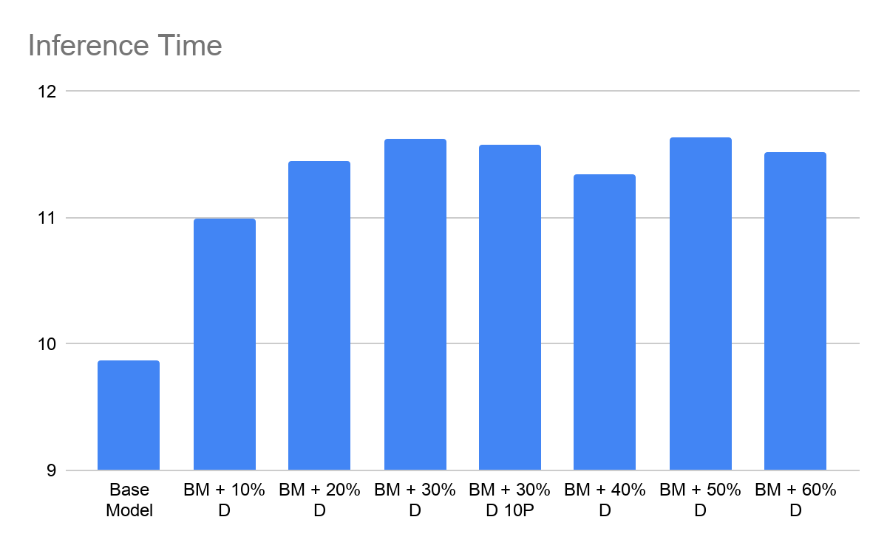
ii) MobileNetV2
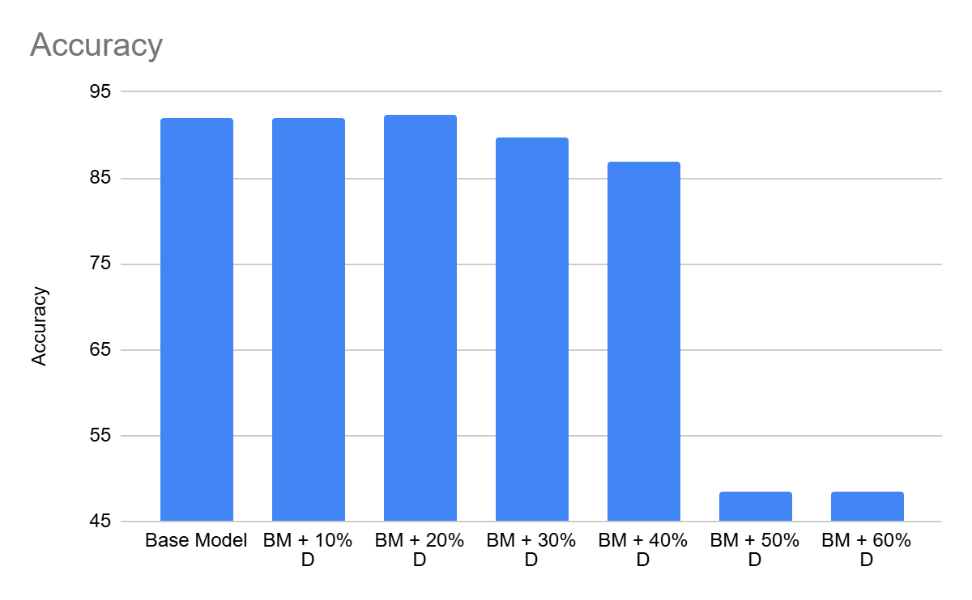
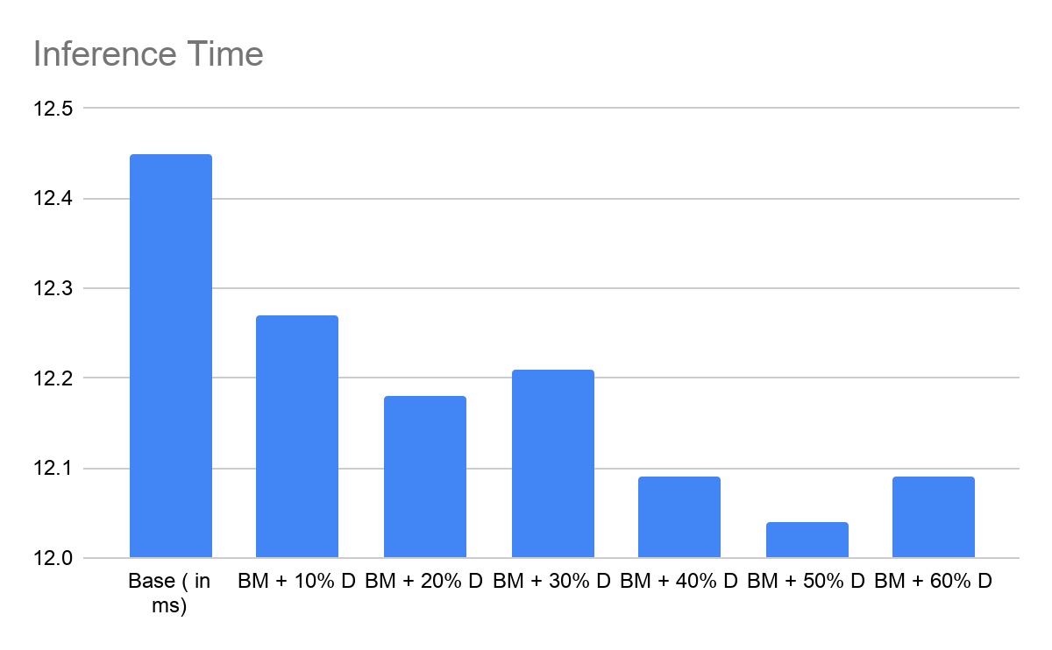
iii) ResNet50
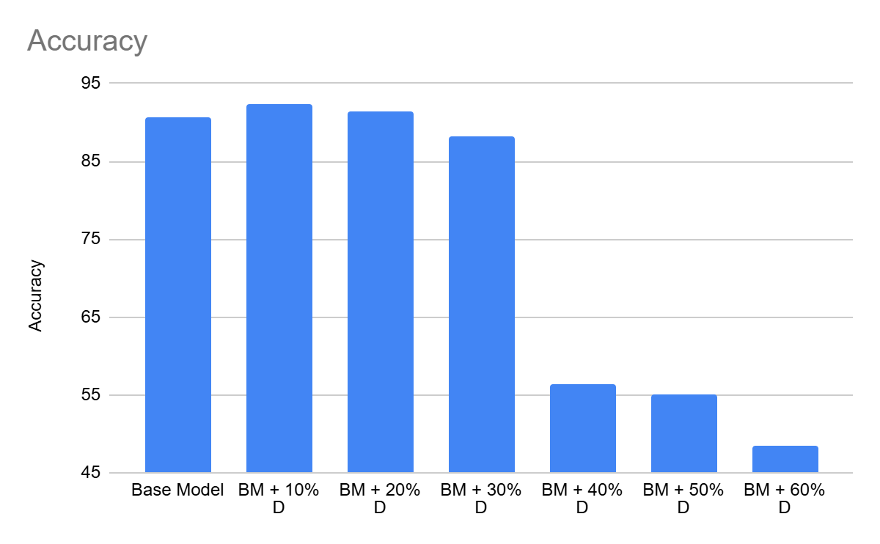
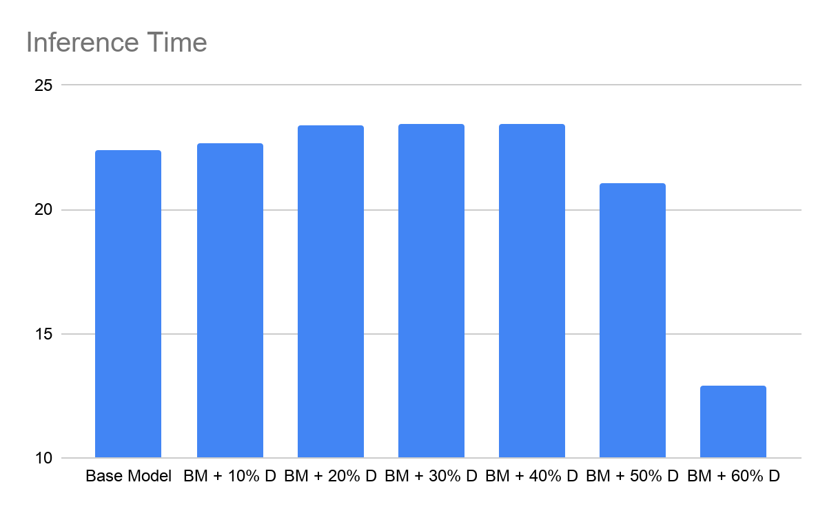
3: Quantization Experiments:
Quantization was performed by reducing the numerical precision of the model weights and activations from floating-point representations to lower-bit integer formats, thereby decreasing model size and computational requirements. Quantized models were generated using INT16, INT8, and INT4 precision and evaluated to analyze the trade-off between memory efficiency, inference performance, and classification accuracy.
i) VGG16

ii) MobileNetV2
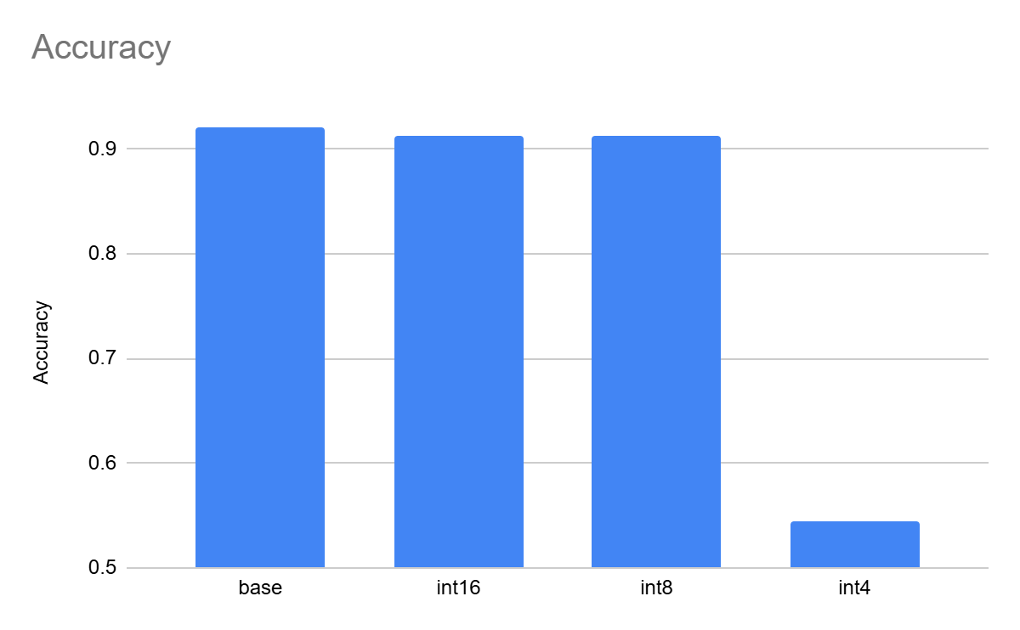
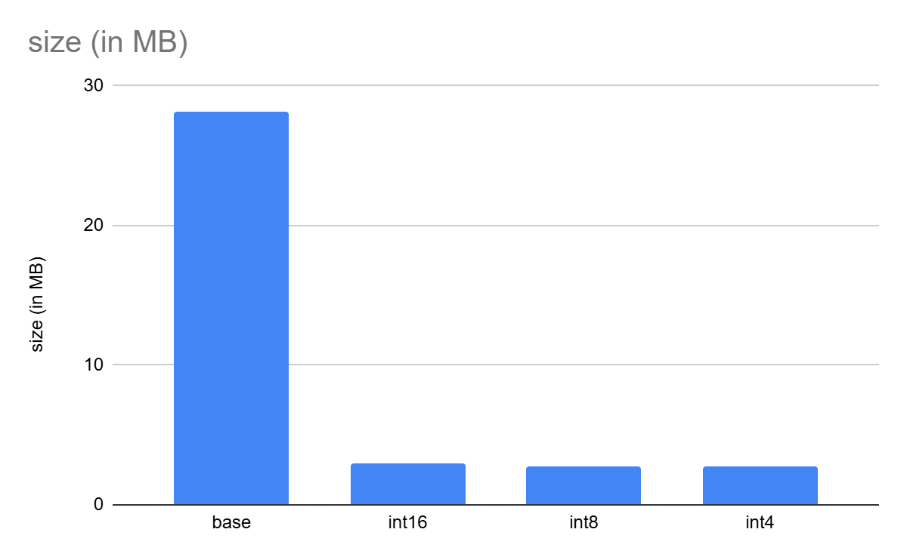
iii) ResNet50
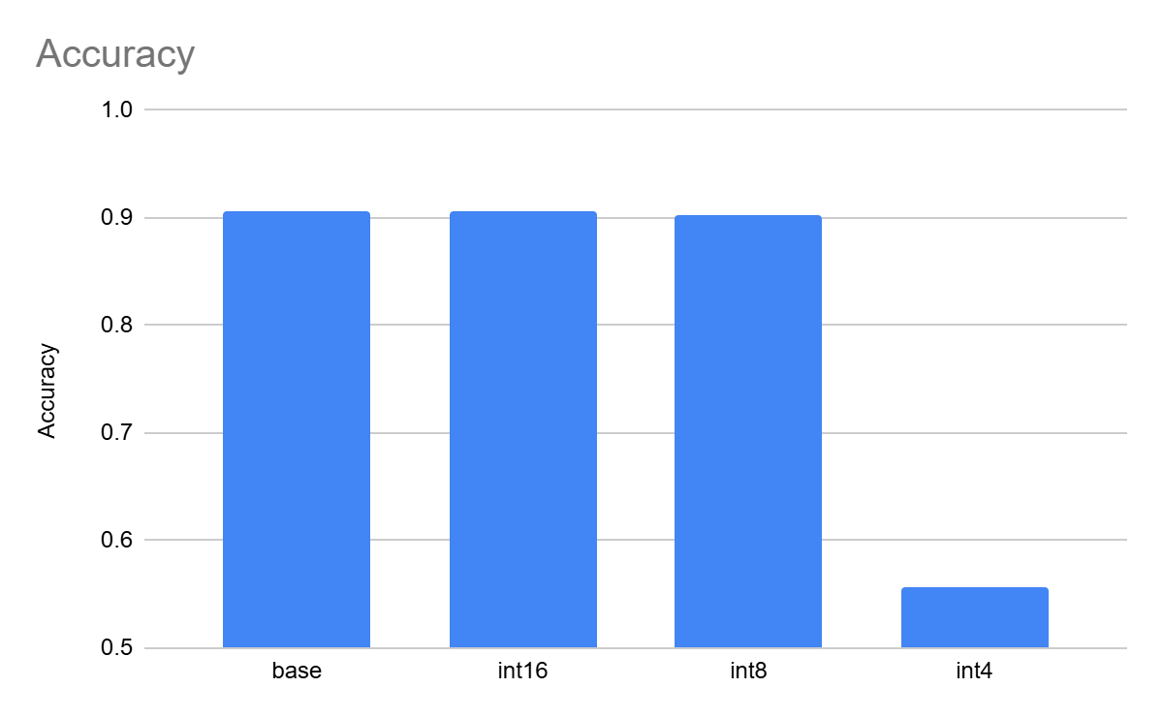
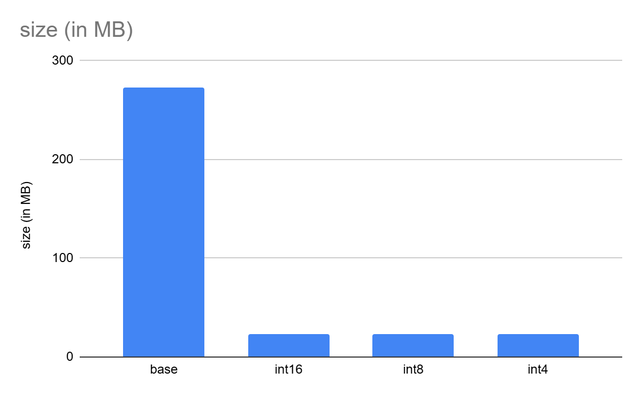
4: Neuron Pruning:
Fully connected layer pruning experiments were conducted on the VGG16 architecture.
Neuron pruning was performed by identifying and removing less significant neurons from the fully connected layers based on their L1 - Norm importance scores, thereby reducing the size of the classifier without altering the convolutional feature extractor. The pruned model was subsequently fine-tuned to restore classification performance and evaluate the impact of reduced dense layer complexity on overall accuracy and model efficiency.
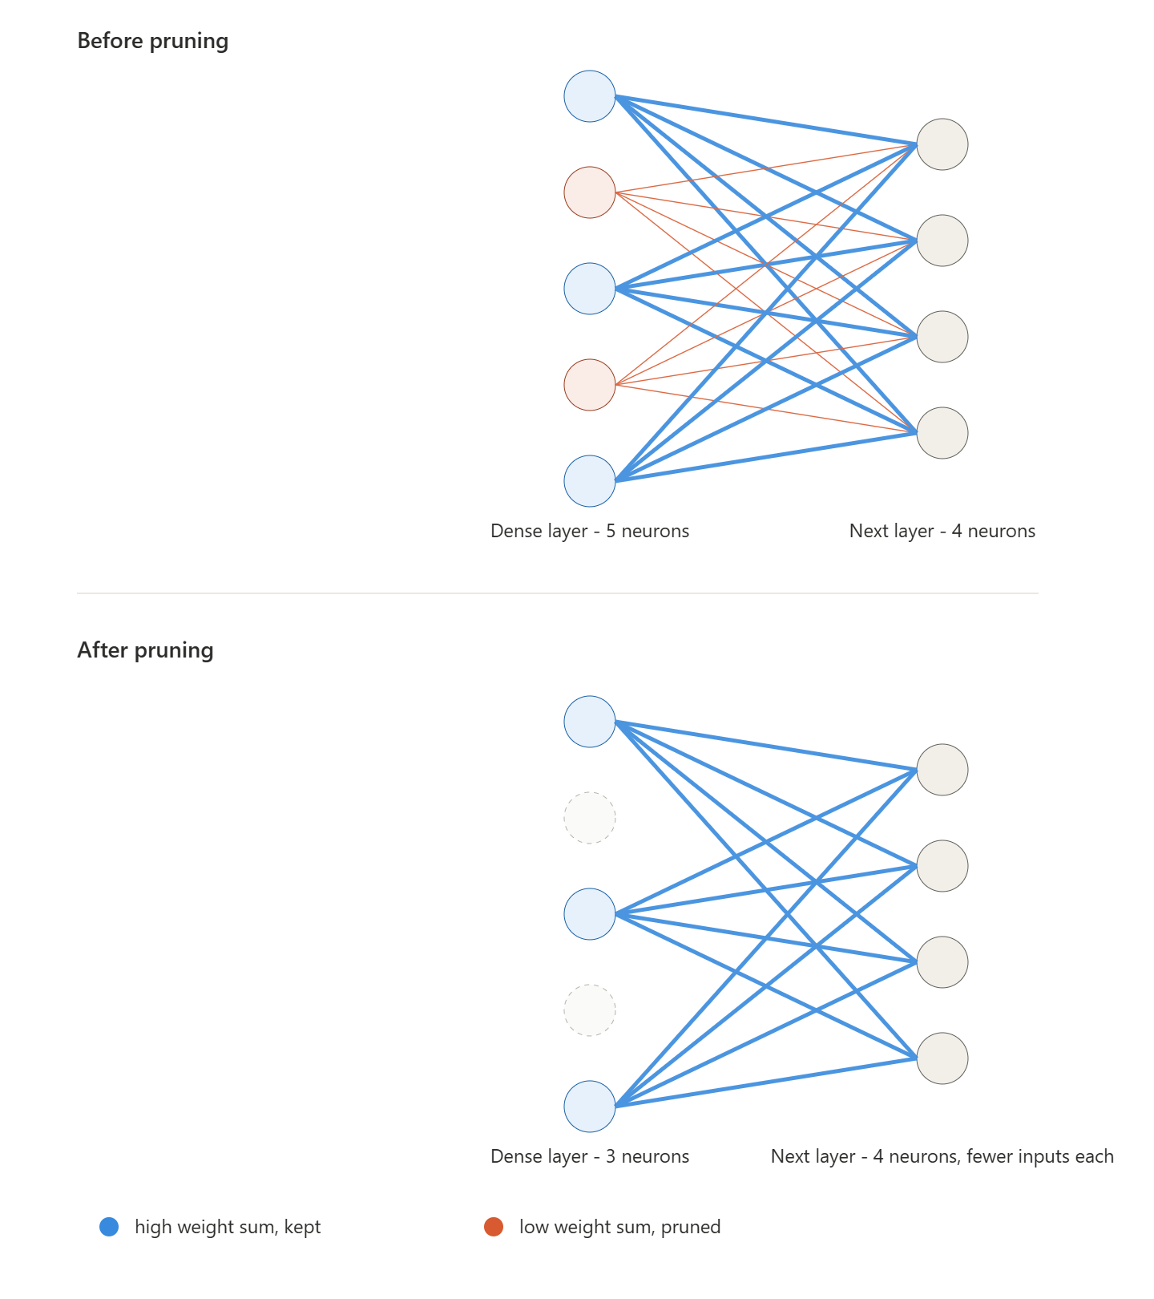

i) VGG16
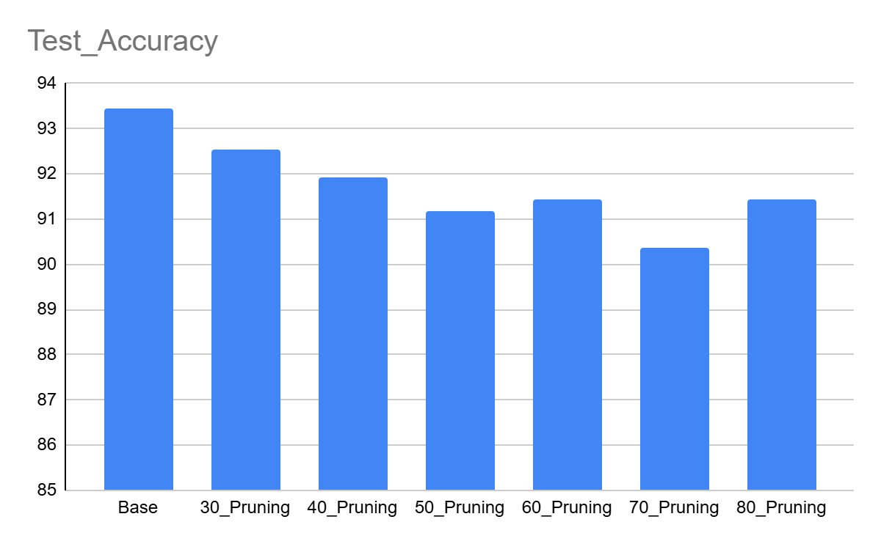
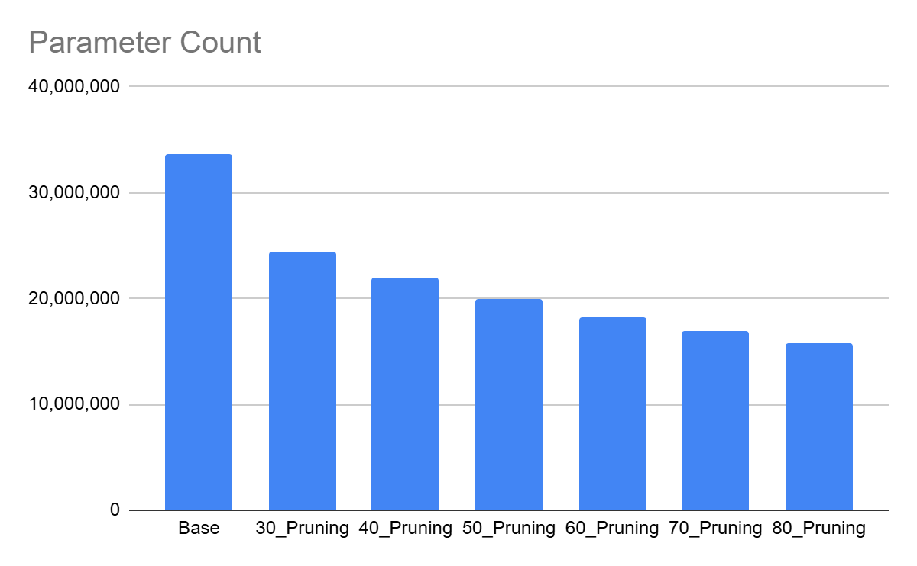
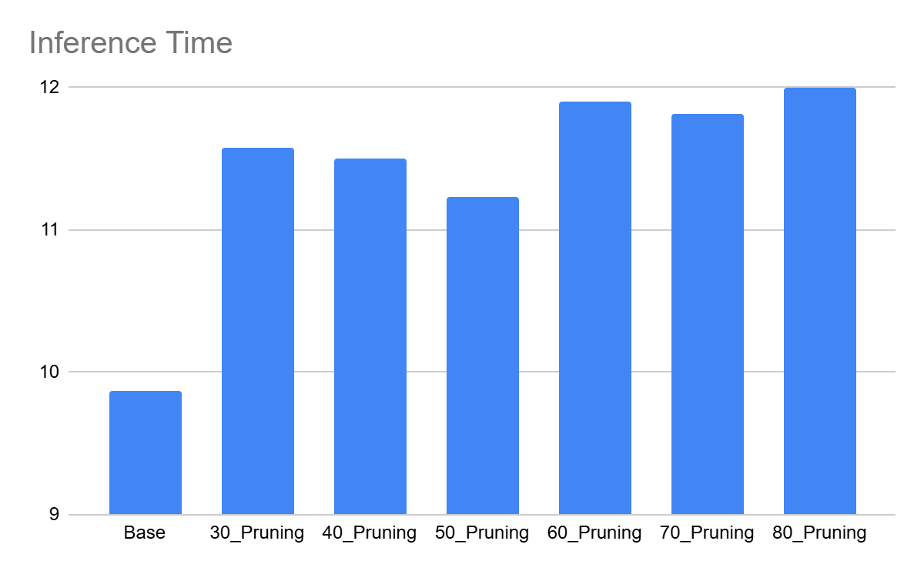
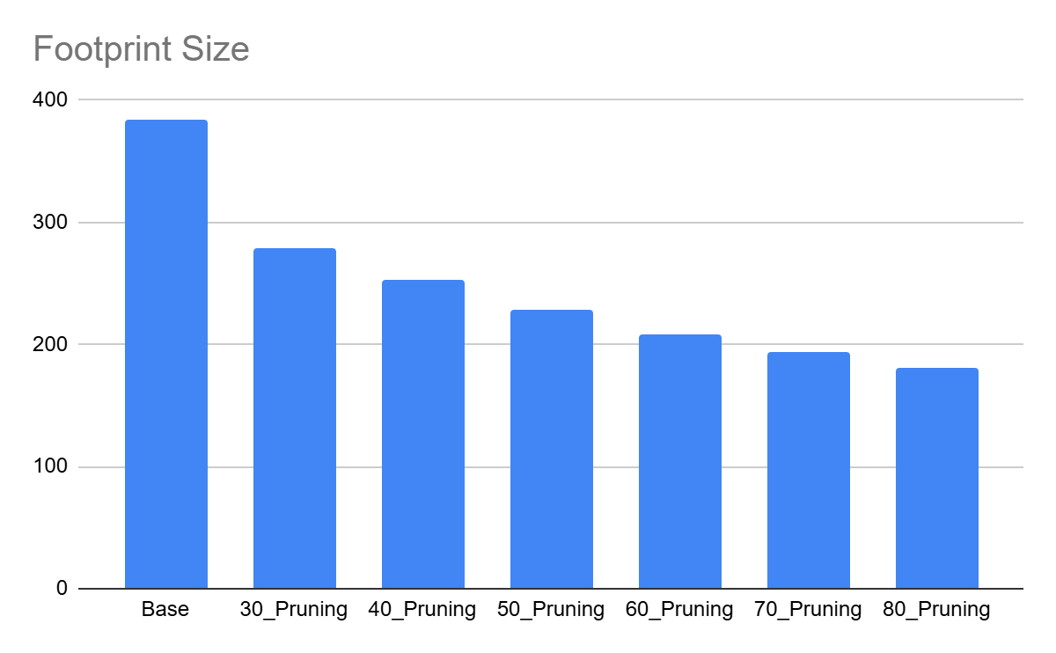

5: Layer Pruning:
Layer pruning was performed by removing convolution layers (VGG16) or complete residual (ResNet50) or inverted residual blocks (MobileNetV2) from the network architecture, thereby reducing its depth and computational complexity. The pruned models were reconstructed with the remaining layers, initialized using the retained weights from the baseline model, and fine-tuned to evaluate the impact of reduced network depth on classification accuracy and overall performance.
In MobileNetV2, a single block is made up of these layers, in order:
Expand layer -> Depthwise convolution -> Project layer -> Add layer (adds the block's input back to its output)
In ResNet50, a single block is made up of these layers, in order:
1x1 convolution -> 3x3 convolution -> 1x1 convolution -> Add layer (adds the block's input back to its output)

The blocks are removed based on the impact of the layer on the output;
VGG16 - using the magnitude of the weights of the layer
ResNet50, MobileNetV2 - how much the tensor is changes when it passes the block [( output tensor - input tensor)/ input tensor]
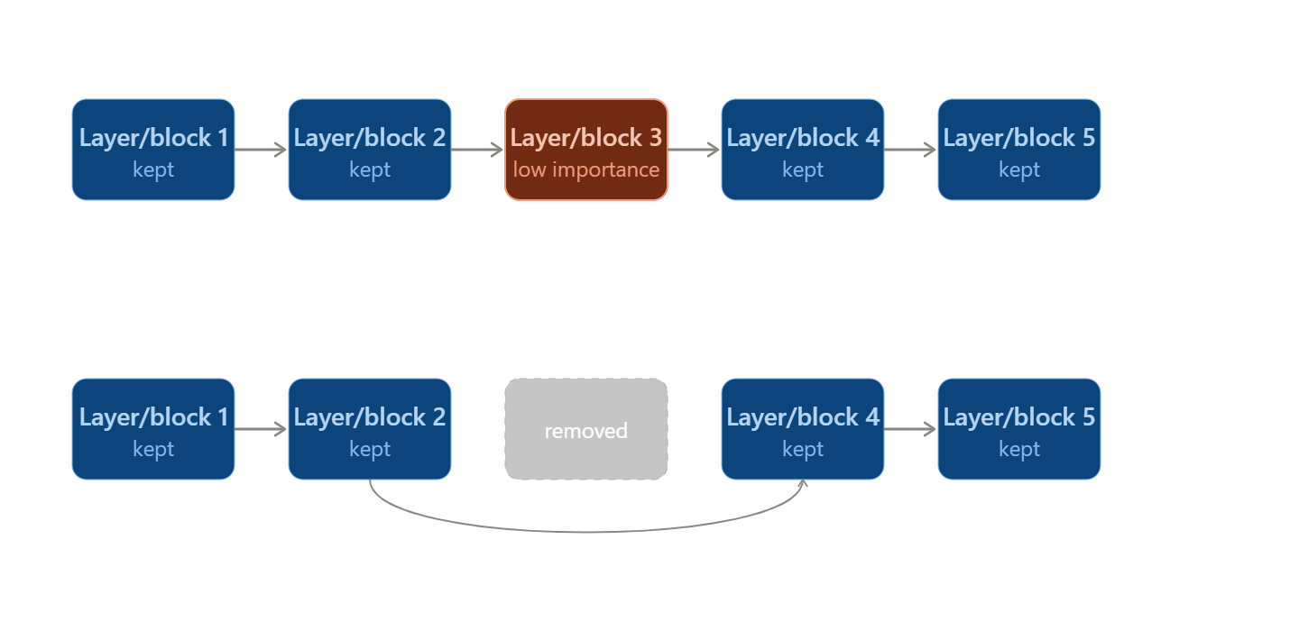
i) VGG16
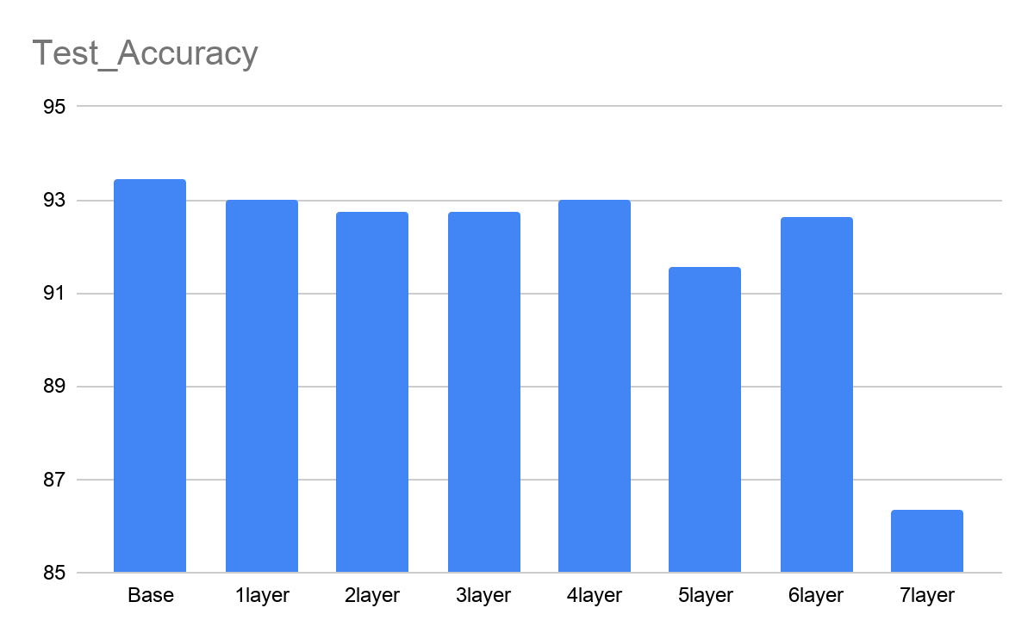
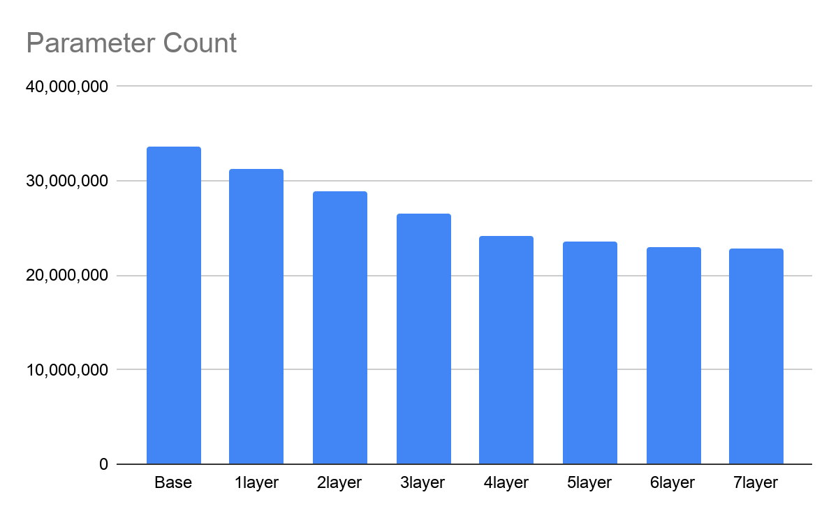
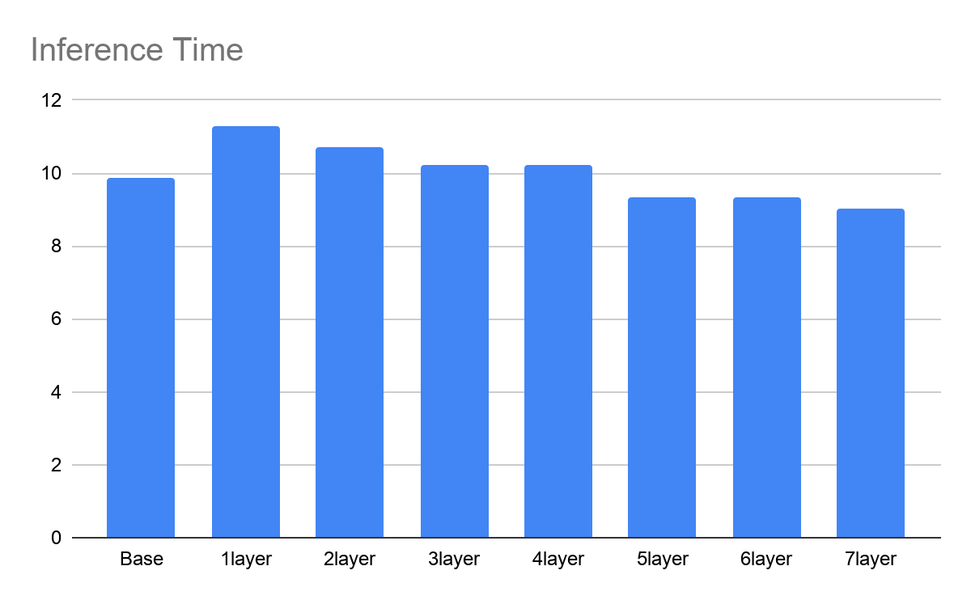
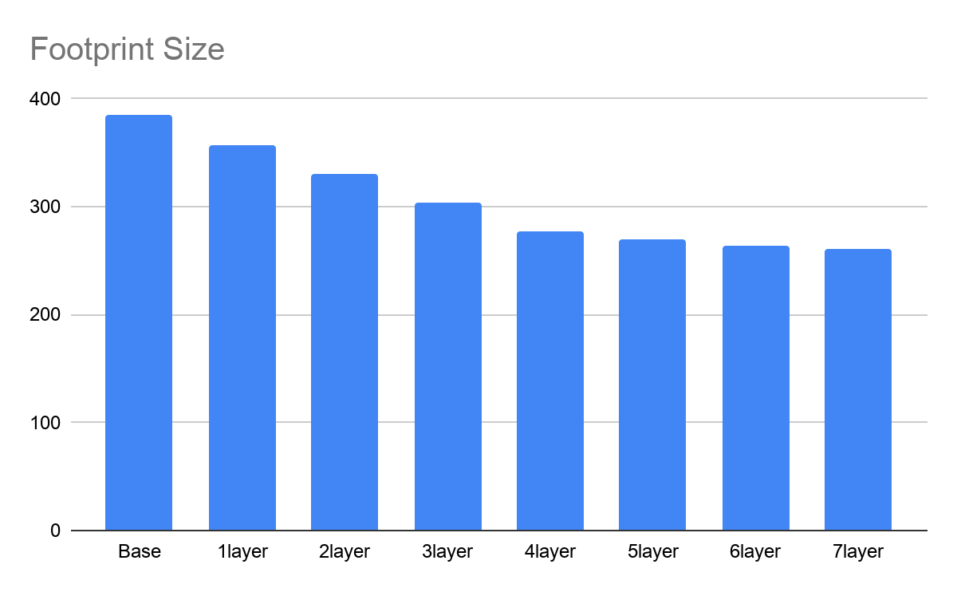

i) MobileNetV2
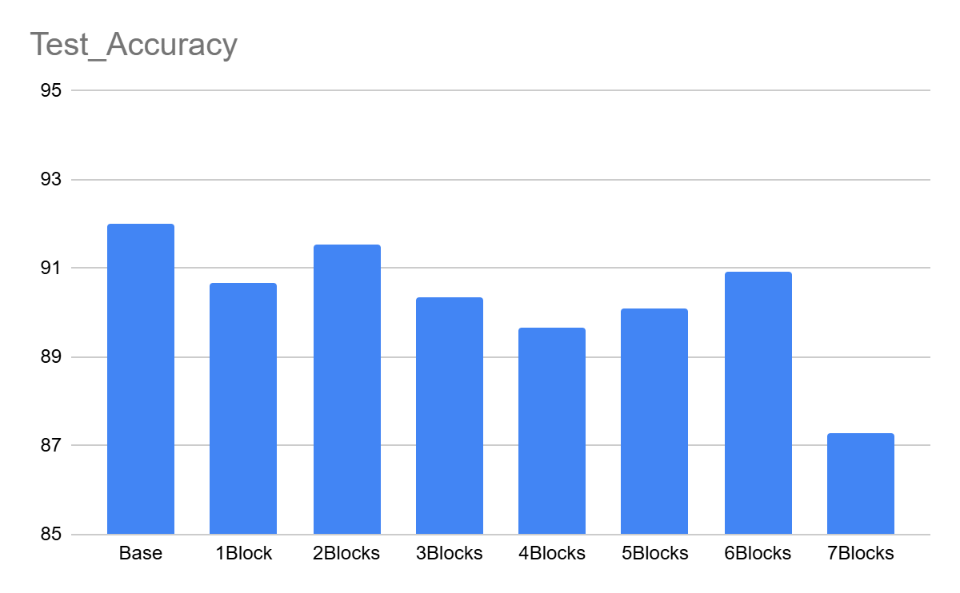
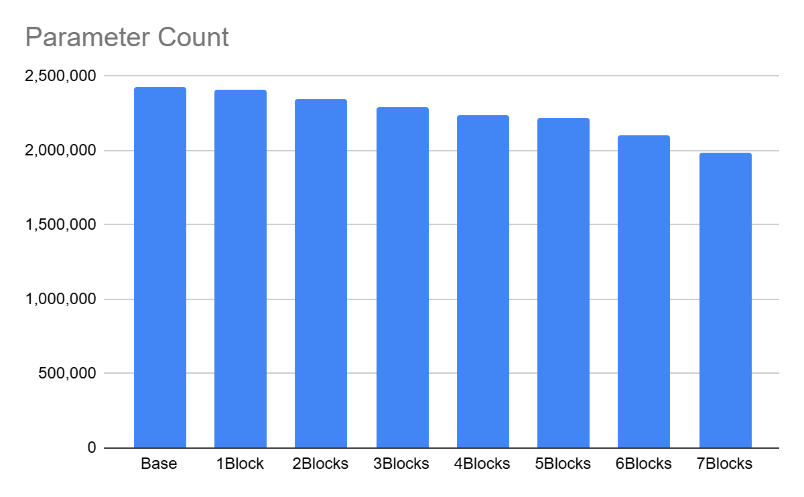
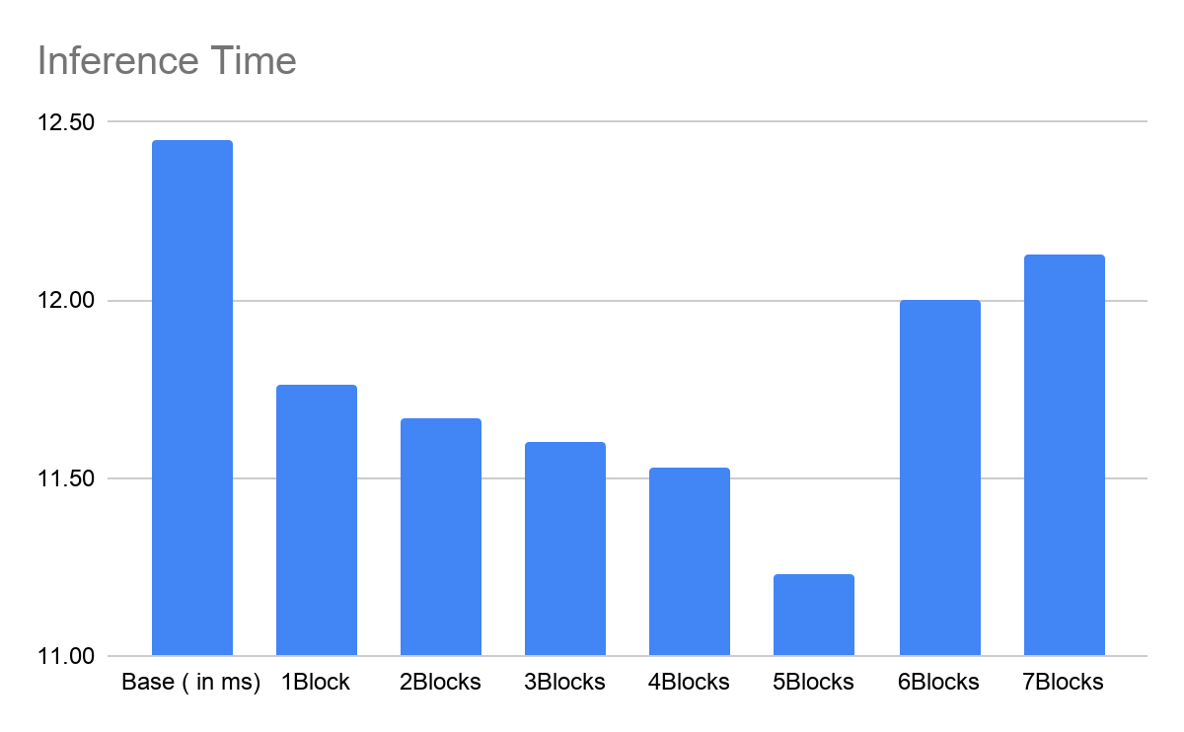
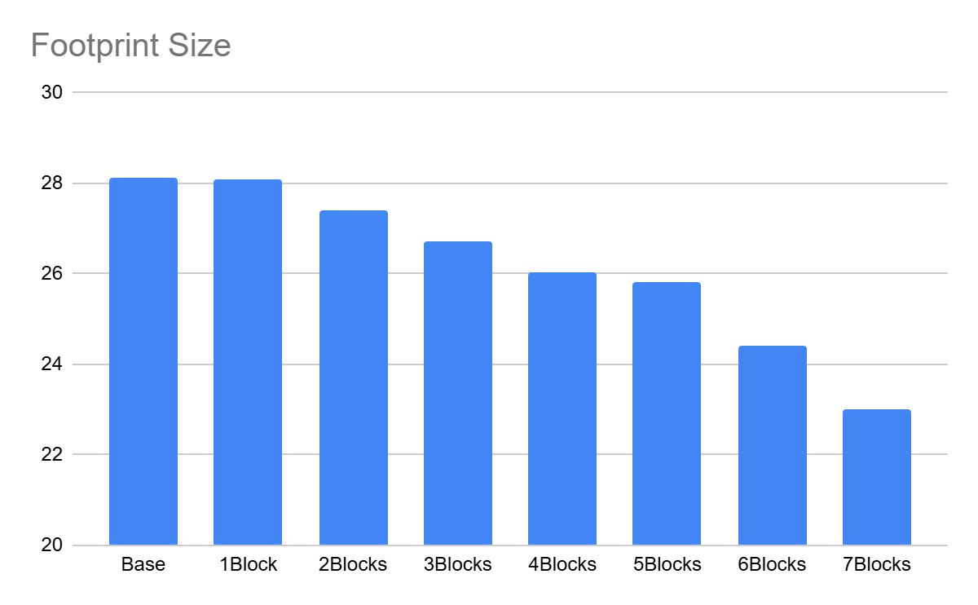

ii) ResNet50
